* -: Now that we're able to submit a form let's actually add some validation to it.
* In the template driven approach, we would simply add required here, for example, to make this field required.
* It doesn't work like this in the reactive approach because keep in mind, and that's key.
* **You're not configuring the form in the template.**
* **You're only synchronizing it with the directives form control name and form group.**
* but you're not configuring it here.
* The TypeScript code that is where you configure it.
* *That is why form control takes more than one argument.*
* *This constructor here you cannot only set the default value.*
* ***The second argument allows you to specify some validators.***
* So you can either only pass one validator here.
* Like for username, where I only want to make sure that it is required.
* And you do this by adding the validators object.
* Make sure to import it from at angle of forms.
* And there you get a couple of built in validators you can use.
* For example, required.
* Now make sure to not call it, to not execute it so don't have parenthesis after it because you don't want to execute this method.
* It is a static method made available by validators here.
* Instead, you only want to ***pass the reference to this method.***

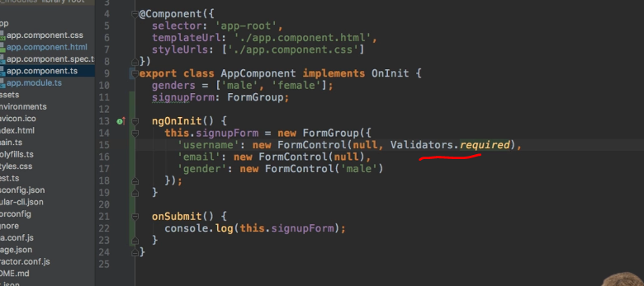

* Angular will execute the method whenever it detects that the input of this form control changed.
* So it just needs to have a reference on what it should execute at this point of time.
* So this is the required validator.
* But as I said this is only one option.
* *You can also add multiple validators by simply passing an array of validators.*
* So here to email, I'm going to pass an array of validators because I want to have the required validator just like on the username.
* But I'll add another validator to here.
* I'll add the email validator.
* And this again all doesn't need to get executed.
* We just need to reference.
* So here I now also passed my validator and now we do have validation in place.

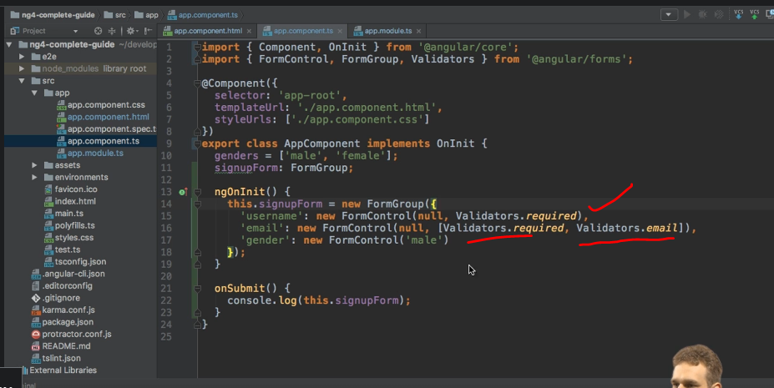

* If we now go back to our form and we inspect and let it reload, and we inspect the email field here for example, it's invalid.

* If I enter something here it's still invalid.
* If I enter email address though, it becomes valid.

* when the same of course for username, it's invalid right now.
* As soon as I enter something it becomes well because it's now not empty anymore.
* So this is how you can add validation to this approach.